Discussion of Data Collection from Electric Man Carrier Trial at MW Mine

To date, there has been a good amount of discussion about what information we would like to record while trialing an electric man carrier at Musselwhite. So far, the most important parameters have been:

* Input Current
* Input Voltage
* Amount of Time Charging

These parameters are important because they will allow us to estimate how much it will cost to “fuel” this equipment over time relative to diesel man carriers.

Ideally we would collect this information as early in the electrical charging system as possible so that our power estimate accounts for inefficiencies in the charging system.

The ideal point to collect this information is at the plug. If we cannot collect this information before the power is converted inside the charging system, then alternatively we could collect the information at the charger and use an estimate of the systems efficiency to back calculate the original power input. In this case we would measure:

* Charger Amps
* Charger Voltage
* Amount of Time Charging

In either case, the energy use could be estimated by taking the ***Average Charging Current*** and multiplying by the ***Average Charging Voltage*** and the ***Charge Time***.

The ideal data read out might look something like the following:

|  |  |  |  |  |
| --- | --- | --- | --- | --- |
| Charging History | | | | |
| Start Time | End Time | Avg. Charge Current | Avg. Charge Voltage | Power Transferred |
| 12/22/2014 15:42 | 12/22/2014 19:30 | 29.3 A | 587.2 V | 65.4 kWhr |

In order to understand the estimate of the charging efficiency, it would be nice to have a map of where power is lost in the charging system. A simple flow diagram would be appreciated to understand how the estimate is made. For example:

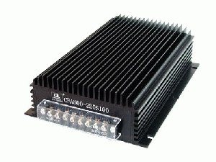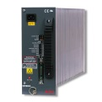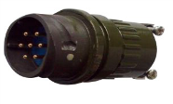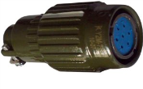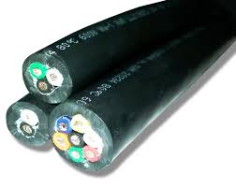

e)

d)

c)

b)

a)

Battery  
(*η* = ~90%)

Internal Rectifier  
(*η* = ~96%)

Internal Transformer (*η* = ~98%)

Plug on Electric Man Carrier

Power Cable at Charging Station

600 Volt Power Cable

Other parameters that have been discussed that seem valuable to collect would include:

1. Continuous State of Charge
2. Odometer
3. The Time the Vehicle is Turned On
4. The Time the Vehicle is Turned Off
5. Vehicle Run Hours
6. Motor Amps/Voltage & Motor Efficiency

Collecting the above data would be valuable for the following reasons:

1. The ***Continuous State of Charge*** could help us put in place guidelines for how often charging needs to happen and how long the vehicle needs to charge before it has a useful amount of charge.
2. The odometer could help us know how drivers like to operate our man carriers.

3 & 4. Vehicle ***Start/Stop Times*** could help us determine when the vehicle is needed during the shift.

1. ***Vehicle Run Hours*** could help us compare costs with diesel man carriers on a per hour basis.
2. Knowing how much power is used by the motor and the efficiency of the motor will allow us to see how much power is used by the other equipment in the man carrier (e.g. radio, A/C, Heat, Lights, etc.).

Other parameters have been discussed, but it is unclear if there would be a benefit to collecting this data. Additional input regarding the value of this data (or any aspect of our data collection) would be welcomed. These include the following:

* Pack Voltage
* Pack Current
* Throttle Input
* Battery Temperatures
* Motor RPM
* Charge Rate Over Time
* Power Regeneration from the Brakes